Practical No 1

Aim: Setup DirectX, window Framework and initialize Direct 3D device

In the practical we are just learning the window framework and initialize a DirectX 3D

Step 1:

1. Create new project and select windows from application and select .NET

Framework as 2.0 in Visual C#

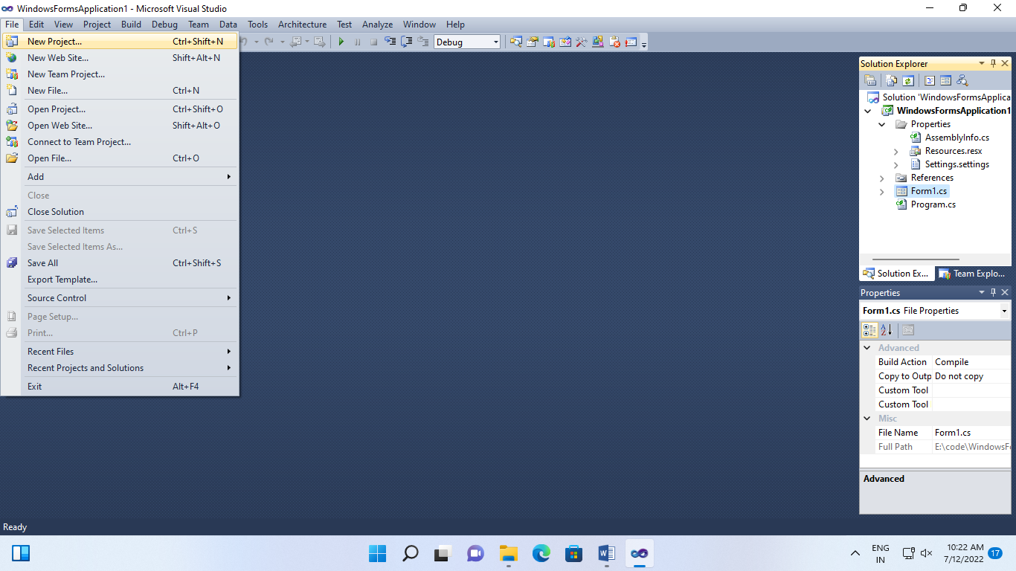

1. Right Click on properties click on open click on build select platform target and select X86

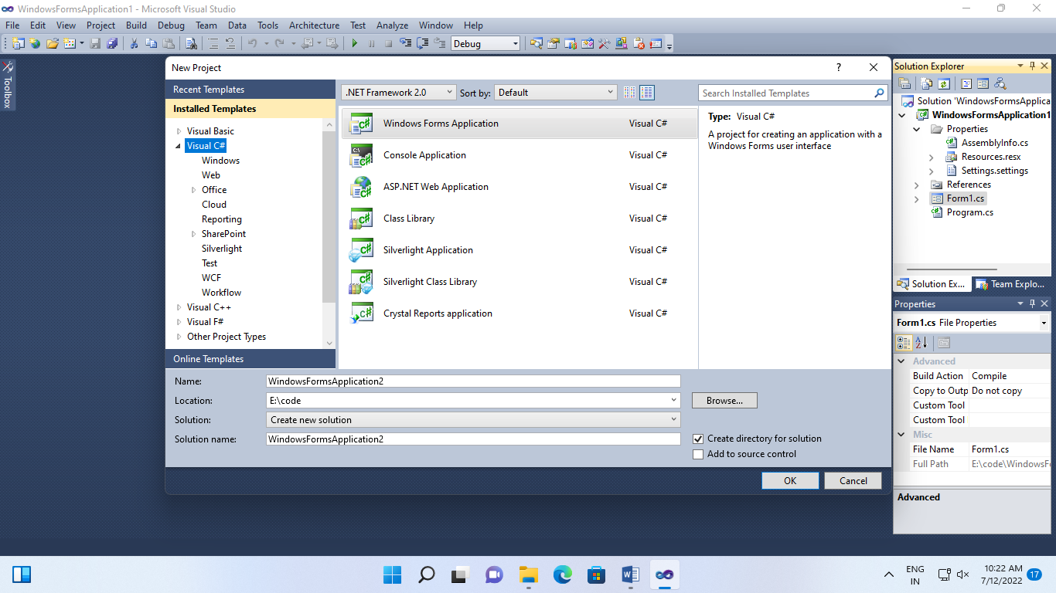

Step 2:

Click on View Code of Form 1

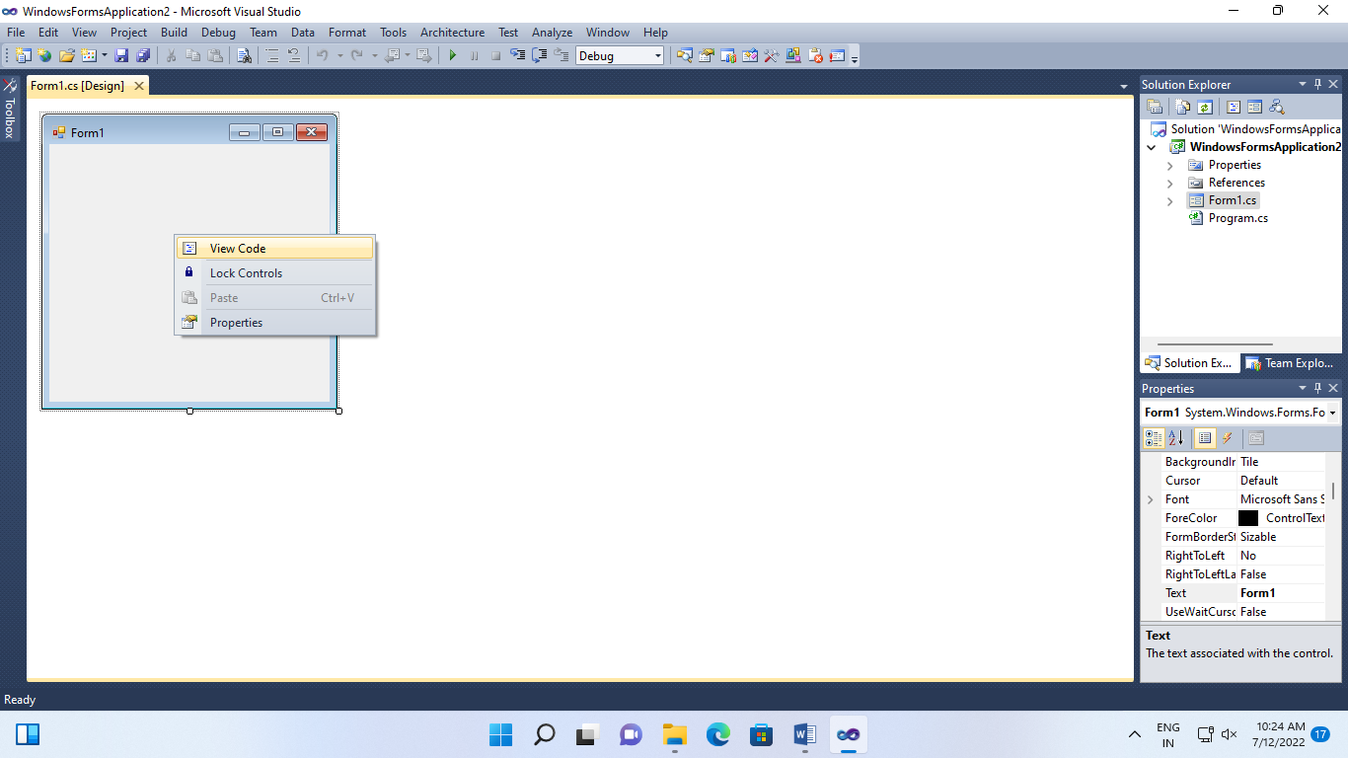

Step 3:

Go to solution explorer right click on project name and select add references click on browse and select the given .dll files which are “Microsoft.DirectX3DX”

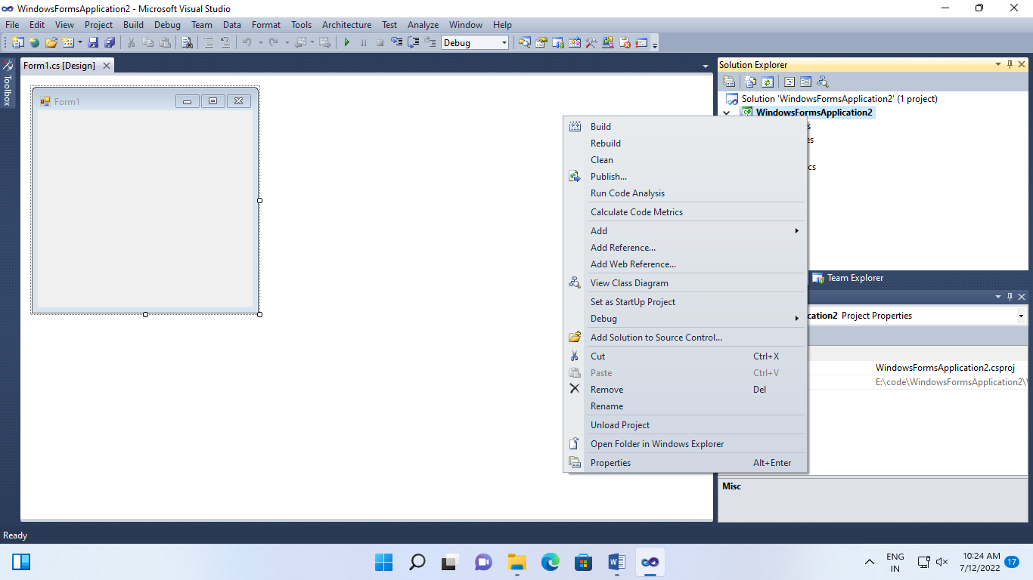

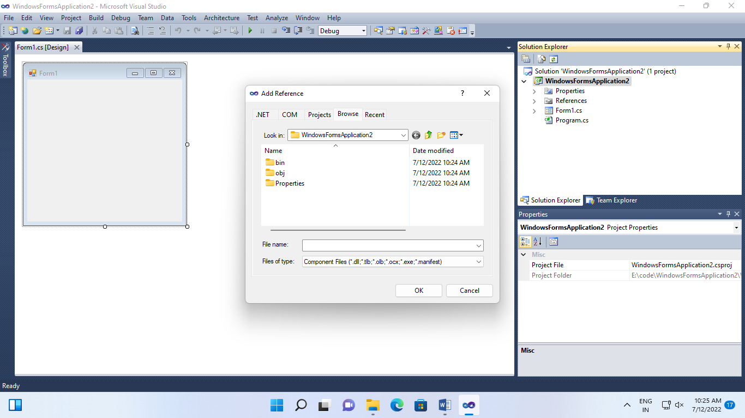

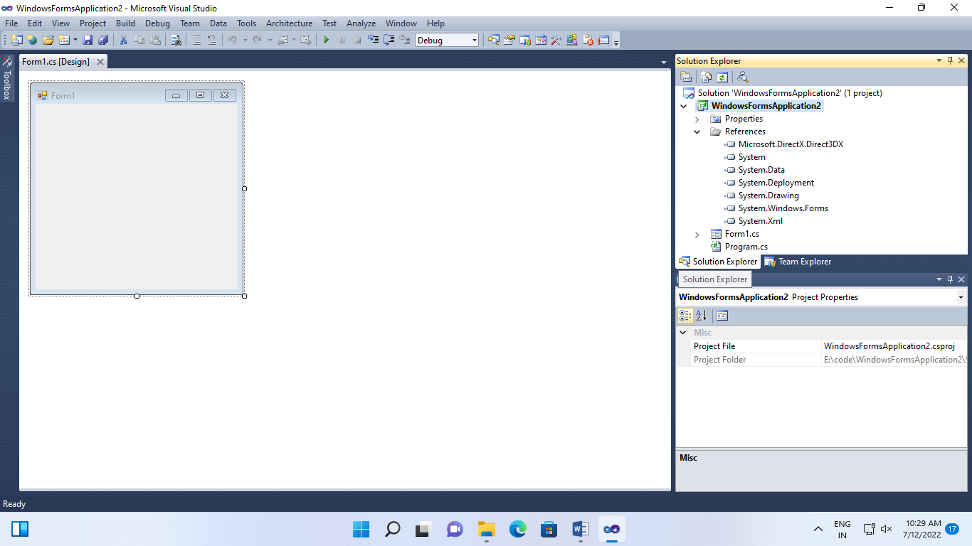

Step 4:

Go to properties section of form (Design) , select paint in the event list and enter as forml_paint

Step 5:

Edit the forms c# code file namespace must be same as your project name

Using.System;

Using.System.Collections.Generic;

Using.System.Component.Model;

Using.System.Data;

Using.System.Grawing;

Using.System.Text;

Using.System.Windows,Forms;

UsingMicrosoft.DirectX;

Using Microsoft.DirectX.Direct3D;

Namespace GP_P1

{

public partial class Form1 : Form

{

Microsoft.DirectX.Direct3D.Device device;

Public Form1()

{

InitializeComponent();

InitDevice();

}

Public void InitDevice()

{

PresentParameterspp = new PresentParameters();

pp.Windowed= true;

pp.SwapEffect= SwapEffect.Discard;

device = mew Device(0, DeviceType.Hardware, this, CreateFlags.HardwareVertexProcssing, pp);

}

private void Render()

{

Device.Clear(ClearFlags.Target, Color.Oragne, 0 , 1);

Device.Present();

}

Private void Form1_Paint(object sender, PaintEventArgs e)

{

Render();

}

}

}